# Name – Devansh Singh

**UID – 20BCS9102**

# Section – 20DWWC-43

**Subject – DSA**

# Domain Winning Camp Worksheet (Practice Questions)

**Day 2**

# Problem 1: Chef of the year Code:

#include <bits/stdc++.h> using namespace std; int main() {

// your code goes here int n,m;

cin>>n>>m; map<string,string>m1,m2; map<string,int>m3,m4; for(int i=0;i<n;i++){

string a,b; cin>>a>>b; m1[a]=b;

// m3[b]++;

}

for(int i=0;i<m;i++){ string s;

cin>>s; m3[m1[s]]++; m4[s]++;

}

int mx=0; string s1,s2;

for(auto &i:m4){ if(i.second>mx){

mx=i.second; s2=i.first;

} }

mx=0;

for(auto &i:m3){ if(i.second>mx){

mx=i.second; s1=i.first;

} }

cout<<s1<<'\n'<<s2; return 0;

}

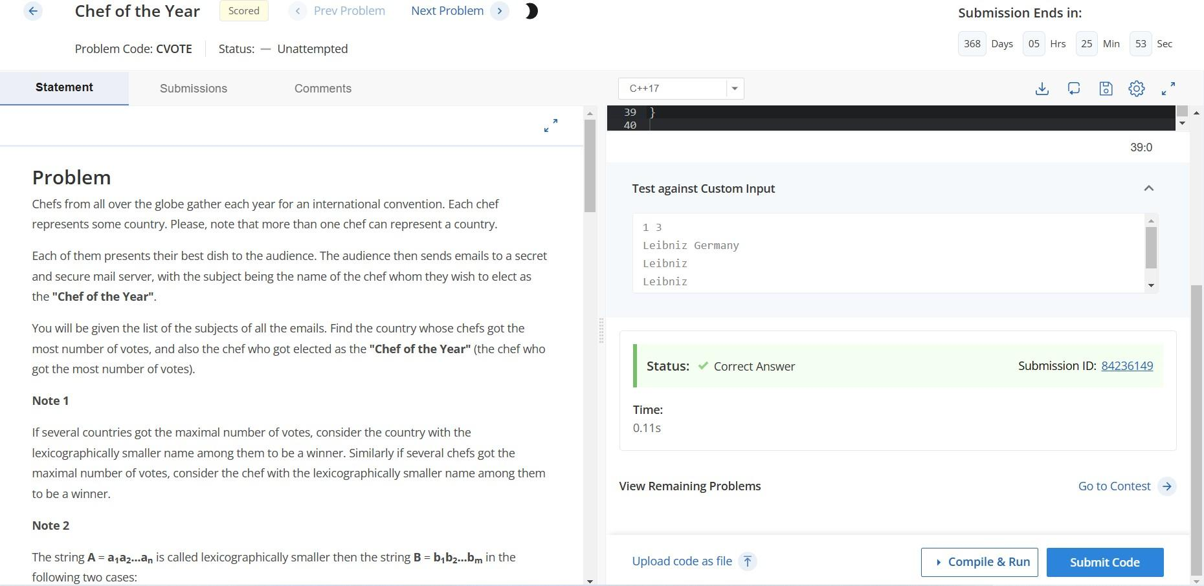

# Problem 2: How many Unattempt Code:

#include <iostream> using namespace std; int main() {

int x,y; cin>>x>>y; cout<<x-y; return 0;

}

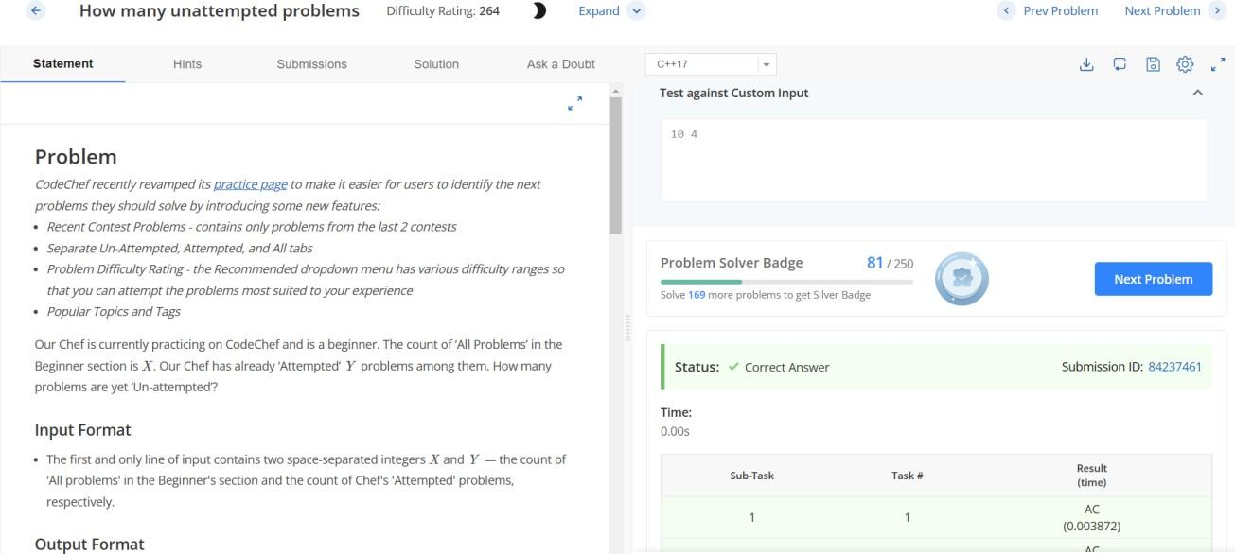

# Problem 3: Total Prize Money Code:

#include <iostream>

using namespace std; int main() {

int t; cin>>t;

for (int i = 0; i < t; i++){ int x, y;

cin>>x>>y;

cout<<10*x + 90*y<<endl;

}

return 0;}

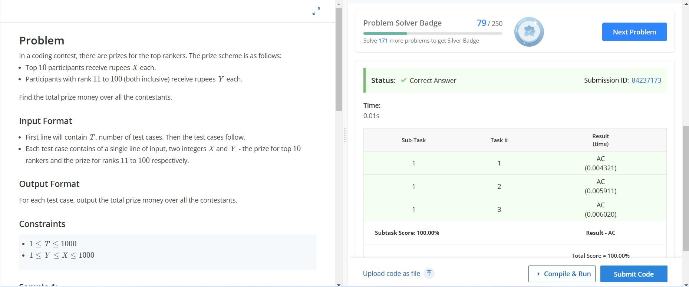

# Problem 4: Chef and Choclates Code:

#include <iostream>

using namespace std; int main() {

int t,x,y,z,n; cin>>t; while(t--){

cin>>x>>y>>z; n=((5*x+10*y)/z); cout<<n<<endl; }

return 0;}

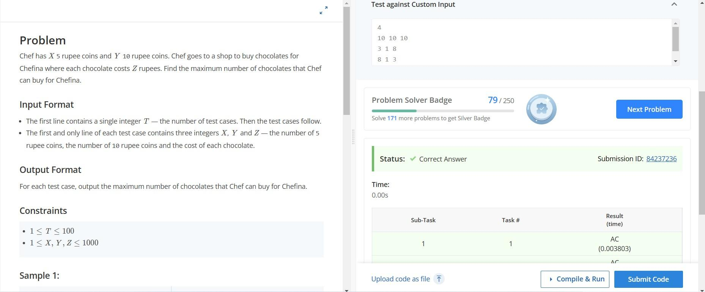

**Problem 5: Atm Code:**

#include <bits/stdc++.h>

using namespace std; int main(){

ios_base::sync_with_stdio(false); cin.tie(0);

cout.precision(2); int a;

float b;

cin >> a >> b;

if ((a%5==0) && (b-a-0.5>=0)) {

cout << fixed << b-a-0.5 << endl;

}

else

{

cout << fixed << b << endl;

}

return 0;

}

# OUTPUT:

